Replacement fresh water tanks for Starlight yachts.

Many of the earlier Starlight yachts were fitted with a flexible water tank manufactured by a company called Air Cushion Ltd. in Southampton. This company no longer exists as far as we could discover when we decided to install a new flexible water tank to our 39, Valinor.
After a longish search on Google, we telephoned a company in Avon that had an employee who worked for Air Cushion Ltd. We were put in touch with Duratank Ltd, based at Unit 43, South Hampshire Industrial Park, Totton, Southampton, SO40 3SA. Telephone number is
023 8087 1188 and fax number 023 8087 1799. Email address: sales@duratank.com
Website address: www.duratank.co.uk the contact there is Malcolm Cox and amazingly he discovered that he had on file the original design plans for the flexible fresh water tank as supplied to the first Sadler 38, forerunner to the Starlight 39. The only problem was that he was missing one or two dimensions and templates which we were able to supply taken from our own boat after we hade dismantled the starboard side bench under which is located the tank. This is not difficult but does need a good power screwdriver as there are many screws to remove. See photo.
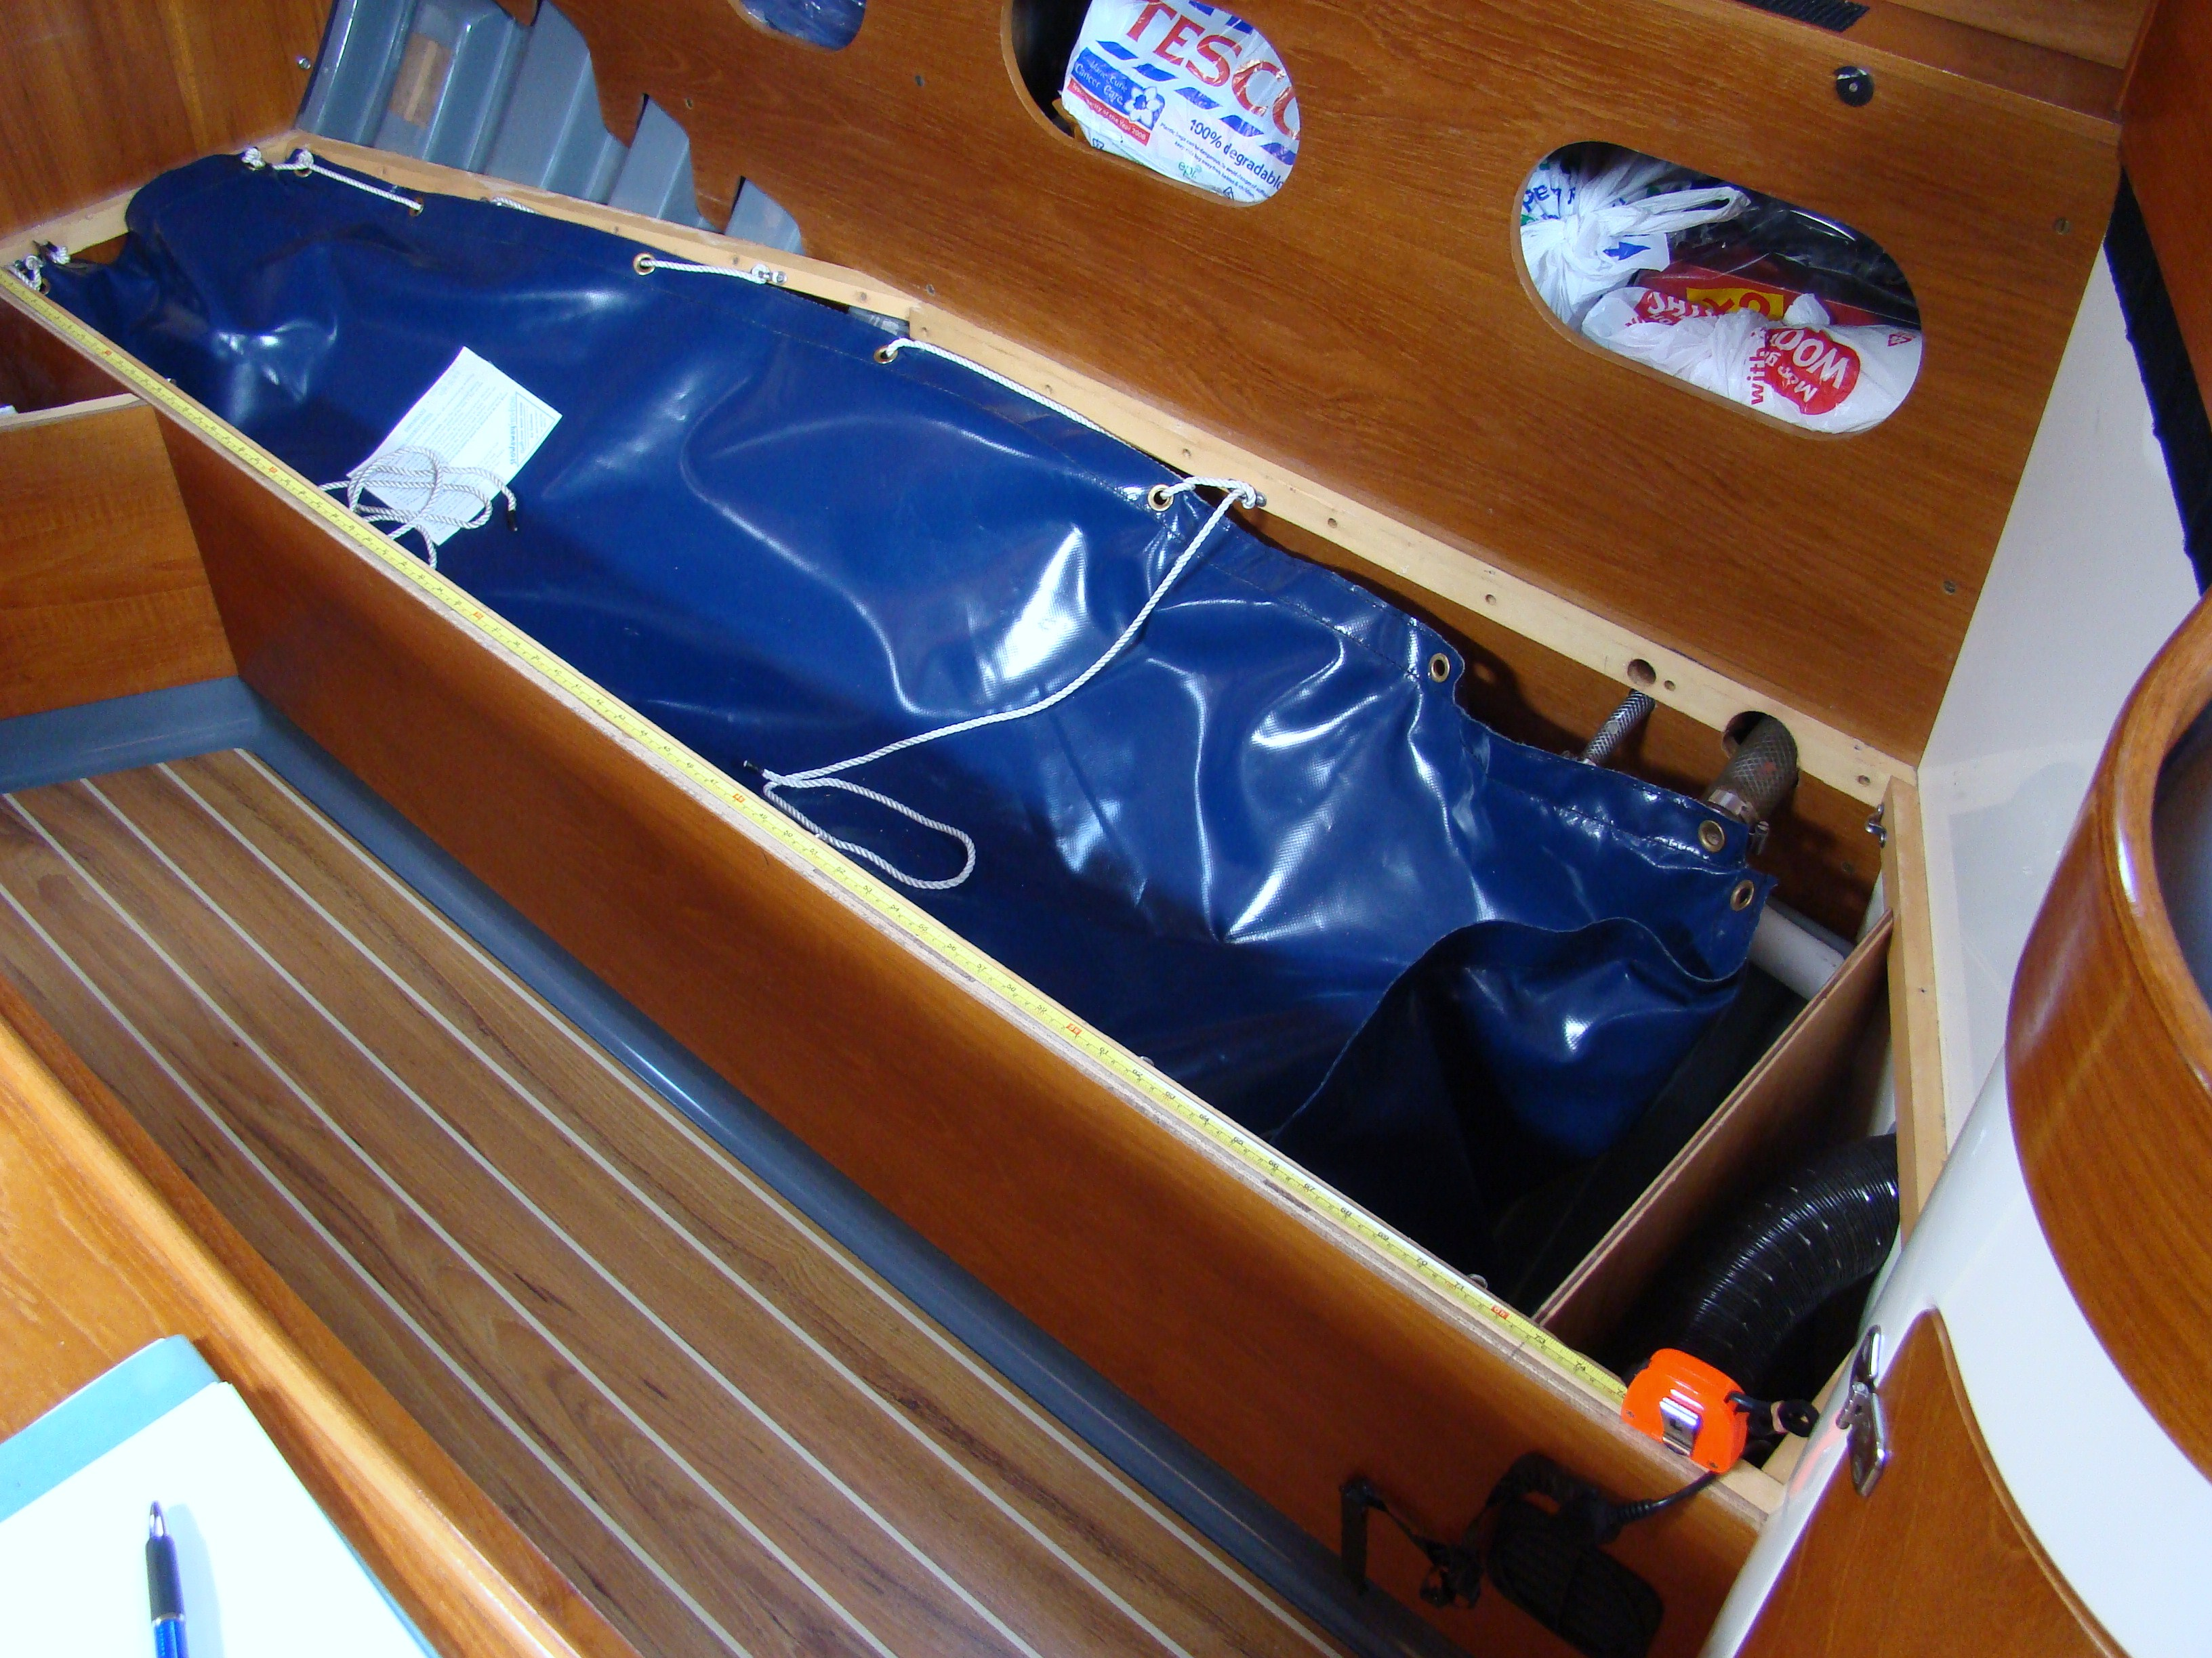

We ordered a new tank and it was completed in five days to a much better specification than the original. Hopefully this information may be helpful to Starlight owners needing replacement water tanks.
John Kibble
17 July 2008

